# **Title: Internal Web Dashboard DNS/Network Troubleshooting Report**

# **Introduction**

Recently, multiple users reported that they are unable to access the internal web dashboard (internal.example.com). The service itself appears up, but users are encountering “host not found” errors. This suggests a DNS resolution problem or a network misconfiguration.

To troubleshoot and resolve the issue, the following steps were taken:

## **Practical Implementation**

To fully understand and demonstrate the troubleshooting steps, I simulated the problem practically in my local lab environment using a virtual machine (VMware Workstation).  
 I intentionally created a DNS resolution issue by modifying the system’s network settings, and then applied the troubleshooting process step-by-step.  
 Screenshots of each command and result are included below to show the investigation and resolution progress clearly.

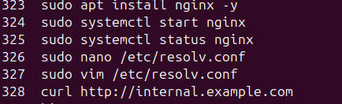I

worked on a Nginx server, and I created a web page and did not write the rest of the settings for it and I ruined the file “ /etc/resolv.conf”

## **1. Verify DNS Settings**

/etc/resolv.conf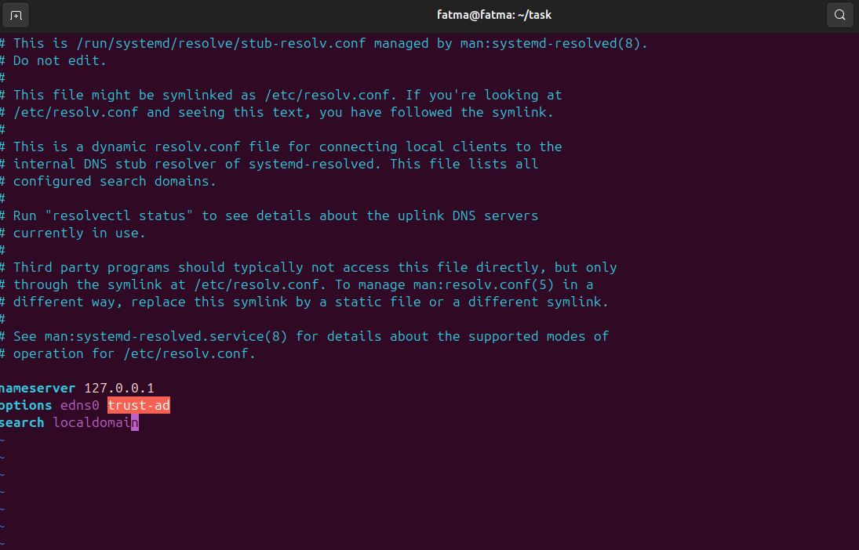

**Explanation:**

* Purpose: Check the current DNS servers used by the system.
* Finding: Incorrect or missing DNS entries were observed.
* Impact: The system cannot resolve internal.example.com.

## **2. Test Name Resolution via External DNS (8.8.8.8)**

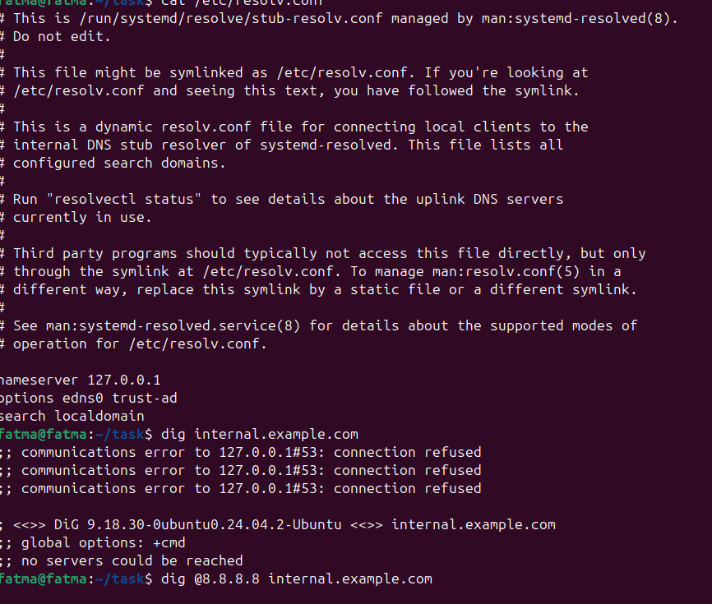

**Explanation:**

* Purpose: Determine if the issue is with internal DNS or the domain itself.
* Finding: Received NXDOMAIN or SERVFAIL errors, meaning the domain is unresolved externally.
* Conclusion: The issue lies within the internal DNS configuration.

## **3. Test Service Reachability**



**Explanation:**

* Purpose: Verify whether the service responds over the network.
* Finding: curl shows “Could not resolve host”, confirming a DNS problem rather than a service failure.

## **4. Bypass DNS using /etc/hosts**

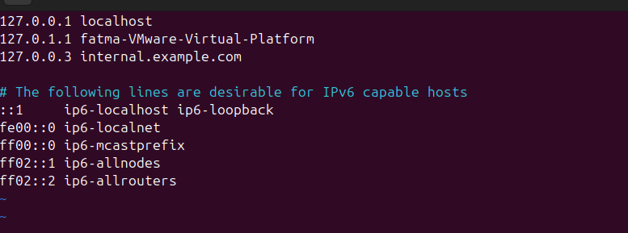

**Explanation:**

* Purpose: Manually map internal.example.com to its IP address.
* Result: Access to the dashboard was successful after adding the entry, confirming that the service itself is running properly.

## **5.Diagnose Service Reachability**

**Purpose:**

* Check if the service is reachable.
* Check if the server is listening on port 80

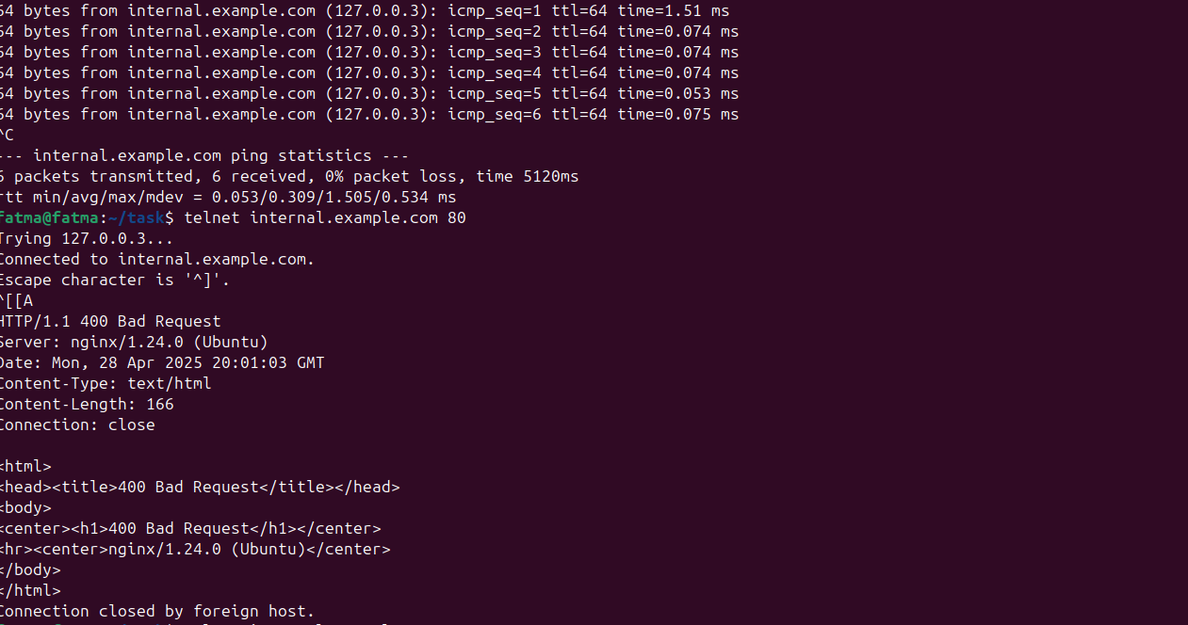

# **6. Possible Causes List**

* Wrong DNS server configuration.
* Missing or wrong DNS record for internal.example.com.
* Firewall blocking port 80.
* Web service not listening properly.
* Host file misconfigured.
* Network routing issue.